1. Which picture shows $\frac{1}{2}$ (half) of the rectangle shaded?

|  |  |  |  |  |  |  |  |  |  |  |  |  |  |  |  |
| --- | --- | --- | --- | --- | --- | --- | --- | --- | --- | --- | --- | --- | --- | --- | --- |
| a) |  |  |  | b) |  |  |  | c) |  |  |  | d) |  |  |  |
|  |  |  |  |  |  |  |  |  |  |  |  |  |  |  |  |

2. Which picture shows $\frac{1}{3}$ (one third) of the rectangle shaded?

|  |  |  |  |  |  |  |  |  |  |  |  |  |  |  |  |
| --- | --- | --- | --- | --- | --- | --- | --- | --- | --- | --- | --- | --- | --- | --- | --- |
| a) |  |  |  | b) |  |  |  | c) |  |  |  | d) |  |  |  |
|  |  |  |  |  |  |  |  |  |  |  |  |  |  |  |  |

3. Which picture shows $\frac{2}{3}$ (two thirds) of the rectangle shaded?

|  |  |  |  |  |  |  |  |  |  |  |  |  |  |  |  |
| --- | --- | --- | --- | --- | --- | --- | --- | --- | --- | --- | --- | --- | --- | --- | --- |
| a) |  |  |  | b) |  |  |  | c) |  |  |  | d) |  |  |  |
|  |  |  |  |  |  |  |  |  |  |  |  |  |  |  |  |

4. Which picture shows $\frac{1}{4}$ (one quarter) of the rectangle shaded?

|  |  |  |  |  |  |  |  |  |  |  |  |  |  |  |  |  |  |  |  |
| --- | --- | --- | --- | --- | --- | --- | --- | --- | --- | --- | --- | --- | --- | --- | --- | --- | --- | --- | --- |
| a) |  |  |  |  | b) |  |  |  |  | c) |  |  |  |  | d) |  |  |  |  |
|  |  |  |  |  |  |  |  |  |  |  |  |  |  |  |  |  |  |  |  |

5. Which picture shows $\frac{2}{4}$ (two quarters) of the rectangle shaded?

|  |  |  |  |  |  |  |  |  |  |  |  |  |  |  |  |  |  |  |  |
| --- | --- | --- | --- | --- | --- | --- | --- | --- | --- | --- | --- | --- | --- | --- | --- | --- | --- | --- | --- |
| a) |  |  |  |  | b) |  |  |  |  | c) |  |  |  |  | d) |  |  |  |  |
|  |  |  |  |  |  |  |  |  |  |  |  |  |  |  |  |  |  |  |  |

6. Which picture shows $\frac{3}{4}$ (three quarters) of the rectangle shaded?

|  |  |  |  |  |  |  |  |  |  |  |  |  |  |  |  |  |  |  |  |
| --- | --- | --- | --- | --- | --- | --- | --- | --- | --- | --- | --- | --- | --- | --- | --- | --- | --- | --- | --- |
| a) |  |  |  |  | b) |  |  |  |  | c) |  |  |  |  | d) |  |  |  |  |
|  |  |  |  |  |  |  |  |  |  |  |  |  |  |  |  |  |  |  |  |

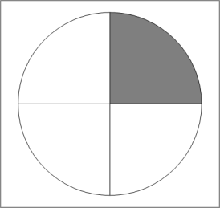7. Which picture shows $\frac{1}{2}$ (half) of the circle shaded?

|  |  |  |  |
| --- | --- | --- | --- |
| a) | b) | c) | d) |

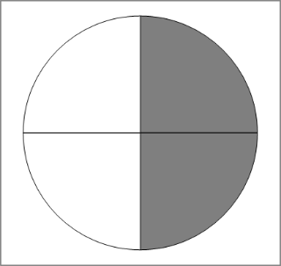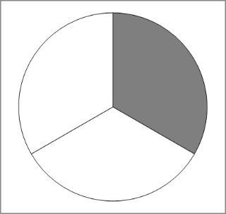

8. Which picture shows $\frac{1}{3}$ (one third) of the circle shaded?

|  |  |  |  |
| --- | --- | --- | --- |
| a) | b) | c) | d) |



9. Which picture shows $\frac{2}{3}$ (two thirds) of the circle shaded?

|  |  |  |  |
| --- | --- | --- | --- |
| a) | b) | c) | d) |

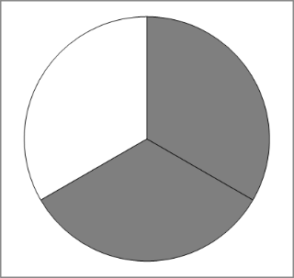

10. Which picture shows $\frac{1}{4}$ (one quarter) of the circle shaded?

|  |  |  |  |
| --- | --- | --- | --- |
| a) | b) | c) | d) |



11. Which picture shows $\frac{2}{4}$ (two quarters) of the circle shaded?

|  |  |  |  |
| --- | --- | --- | --- |
| a) | b) | c) | d) |



12. Which picture shows $\frac{3}{4}$ (three quarters) of the circle shaded?

|  |  |  |  |
| --- | --- | --- | --- |
| a) | b) | c) | d) |



13. Which picture shows $\frac{1}{2}$ (half) of the ribbon shaded?

|  |  |
| --- | --- |
| a) |  |
| b) |  |
| c) |  |
| d) |  |

14. Which picture shows $\frac{1}{3}$ (one third) of the ribbon shaded?

|  |  |
| --- | --- |
| a) |  |
| b) |  |
| c) |  |
| d) |  |

15. M Which picture shows $\frac{2}{3}$ (two thirds) of the ribbon shaded?

|  |  |
| --- | --- |
| a) |  |
| b) |  |
| c) |  |
| d) |  |

16. Which picture shows $\frac{1}{4}$ (one quarter) of the ribbon shaded?

|  |  |
| --- | --- |
| a) |  |
| b) |  |
| c) |  |
| d) |  |

17. Which picture shows $\frac{2}{4}$ (two quarters) of the ribbon shaded?

|  |  |
| --- | --- |
| a) |  |
| b) |  |
| c) |  |
| d) |  |

18. Which picture shows $\frac{3}{4}$ (three quarters) of the ribbon shaded?

|  |  |
| --- | --- |
| a) |  |
| b) |  |
| c) |  |
| d) |  |

19. What fraction of this rectangle is shaded?

a) b)

c) d)

20. What fraction of this rectangle is shaded?

a) b)

c) d)

21. What fraction of this rectangle is shaded?

a) b)

c) d)

22. What fraction of this rectangle is shaded?

a) b)

c) d)

23. What fraction of this circle is shaded?



a) b)

c) d)

24. What fraction of this circle is shaded?



a) b)

c) d)

25. What fraction of this circle is shaded?



a) b)

c) d)

26. What fraction of this circle is shaded?



a) b)

c) d)

27. What fraction of this ribbon is shaded?



a) b) c) d)

28. What fraction of this ribbon is shaded?



a) b) c) d)

29. What fraction of this ribbon is shaded?



a) b) c) d)

30. What fraction of this ribbon is shaded?



a) b) c) d)